

NOTRE DAME UNIVERSITY
BANGLADESH
Lab Task - 01

Course Title: Technical Writing & Presentation Lab
Course Code: CSE 3207

Submitted by:
Name: Istiak Alam
ID: 0692230005101005
Batch: CSE-20
Submission Date: 29-01-25
Assignment Topic: Making Document in Texmaker

Submitted to:
Md. Tahmid Hasan,
Lecturer, Depertment of CSE,
Notre Dame Univesity Bangladesh
Lab Task-01 :
Code in Texmaker :
\documentclass{article}
\begin{document}
\title{Practice Lab-01 :}
\author{Istiak Alam}
\maketitle
In March 2006, Congress raised that ceiling an additional \$0.79 trillion to \$8.97 trillion, which is approximately 68\% of GDP. As of October 4, 2008, the ``Emergency Economic Srabilization Act of 2008" raised the current debt ceiling to \$11.3 trillion.
\end{document}
Output in Texmaker :
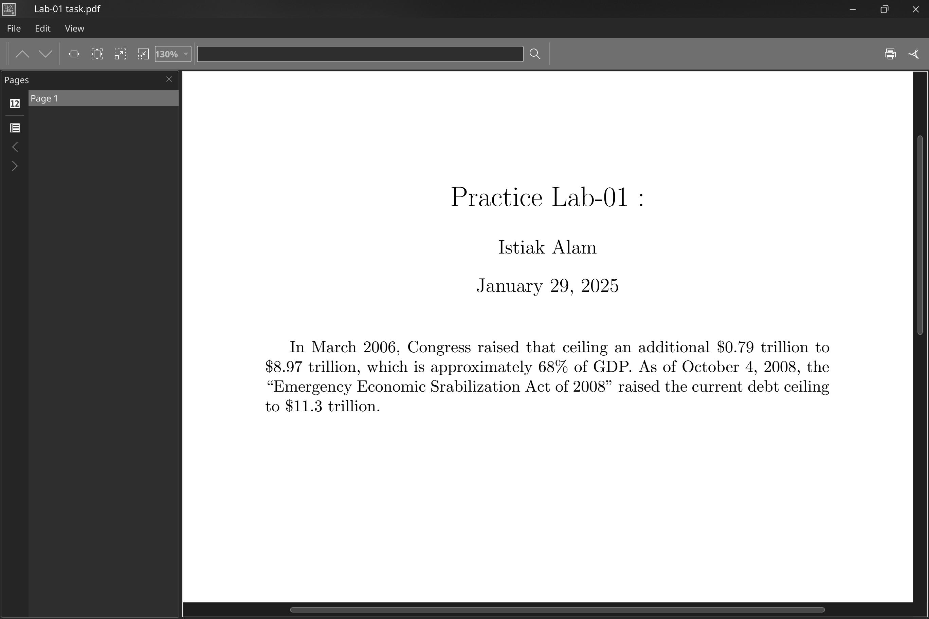Figure 1: Output in Texmaker

